**iWish Software – Manual for the Dictionary Web Application**

This is a simple dictionary application containing all the basic functions as stated in the problem statement.

Must be done before you start the application

First create a Database for which I have given all the sql commands in the db.sql file which you can find in the zip file.

There would be one admin having (command is already in db.sql):

Username : admin

Password : Admin@123

**First ADMIN must be added only through the sql qu**ery and not through registration, as **admin can only add another admin** and all the user who register through the portal would be as **default thought as a usual USER** and not an ADMIN.

**User Portal**

1. Register yourself as a usual user, set password according to all the criterias or else the registration would noy be accepted. Incase the passwords are not as per the expected criteria an error would be shown.

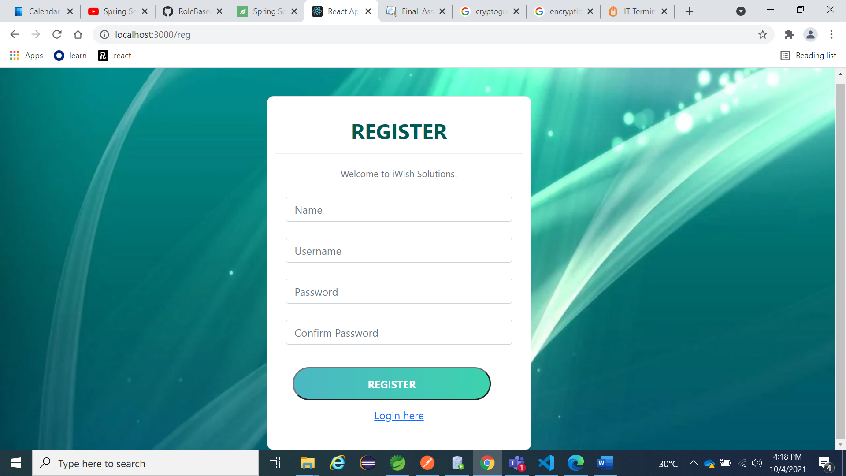

1. Now you would be directly leaded to the User Homepage

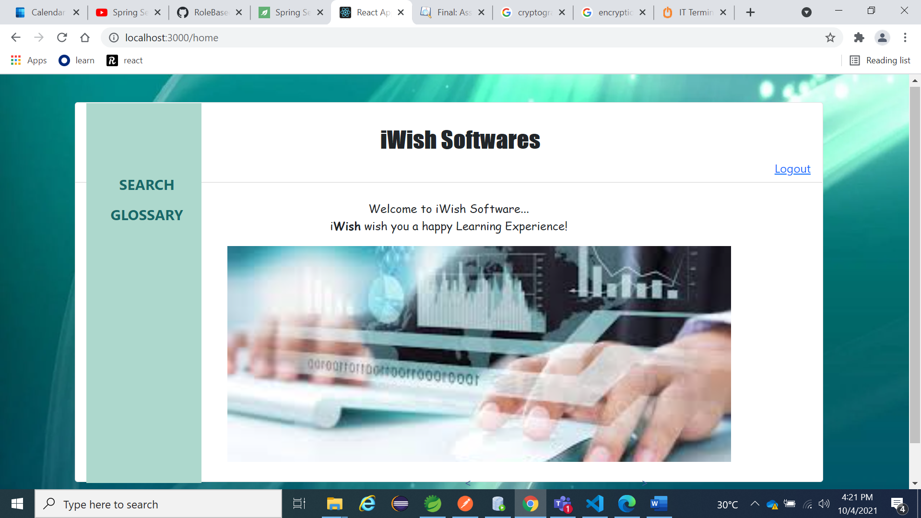

1. As per your choice you’ll be leaded to either the search page or the glossary page.
2. This would be the glossary page which on clicking the word, would take you to a full screen page having the keyword, description and the uploaded pictures

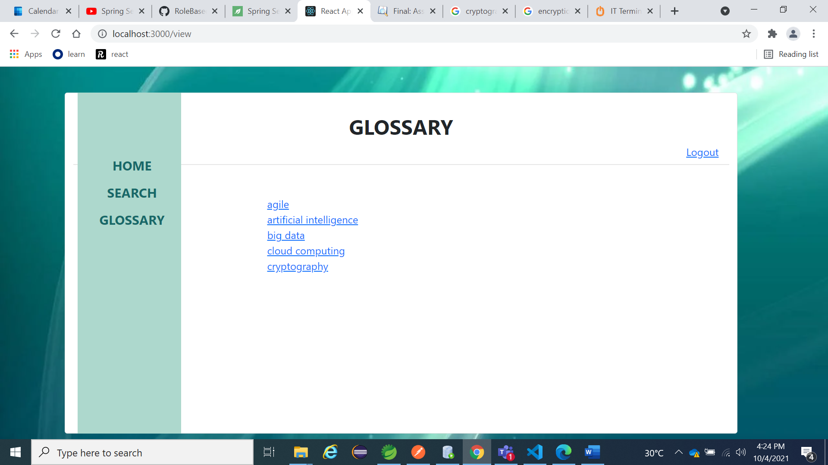

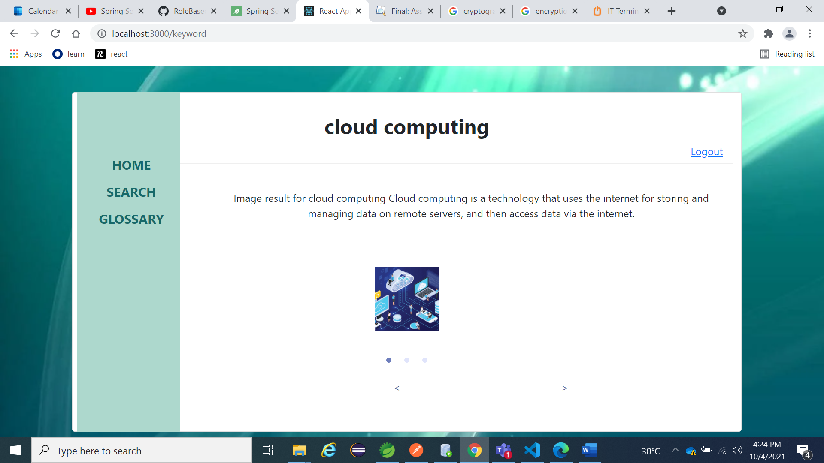

1. Now in case you click the search on the navigation bar.

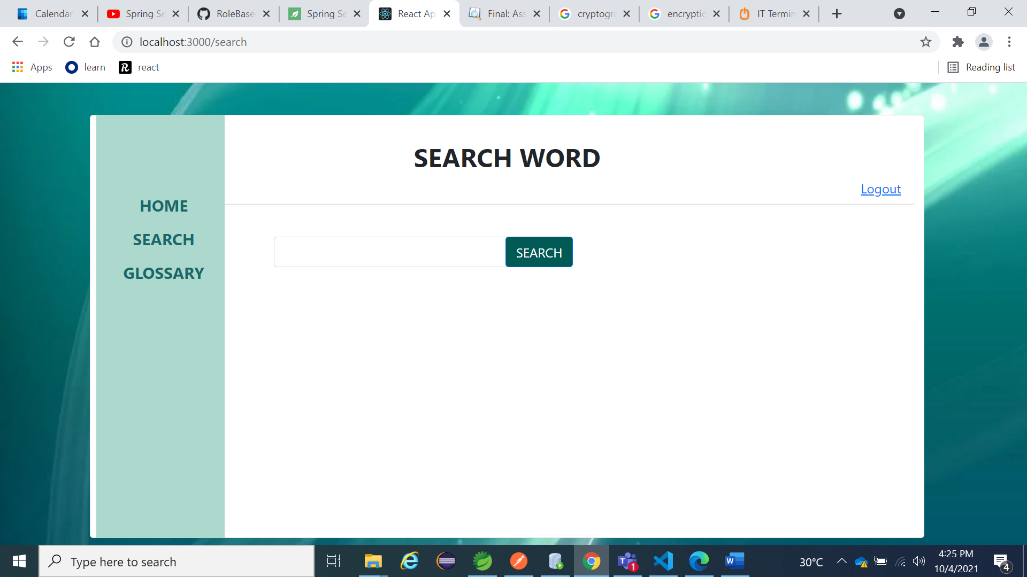

1. Which on search would open a model containing all the information related to the word.

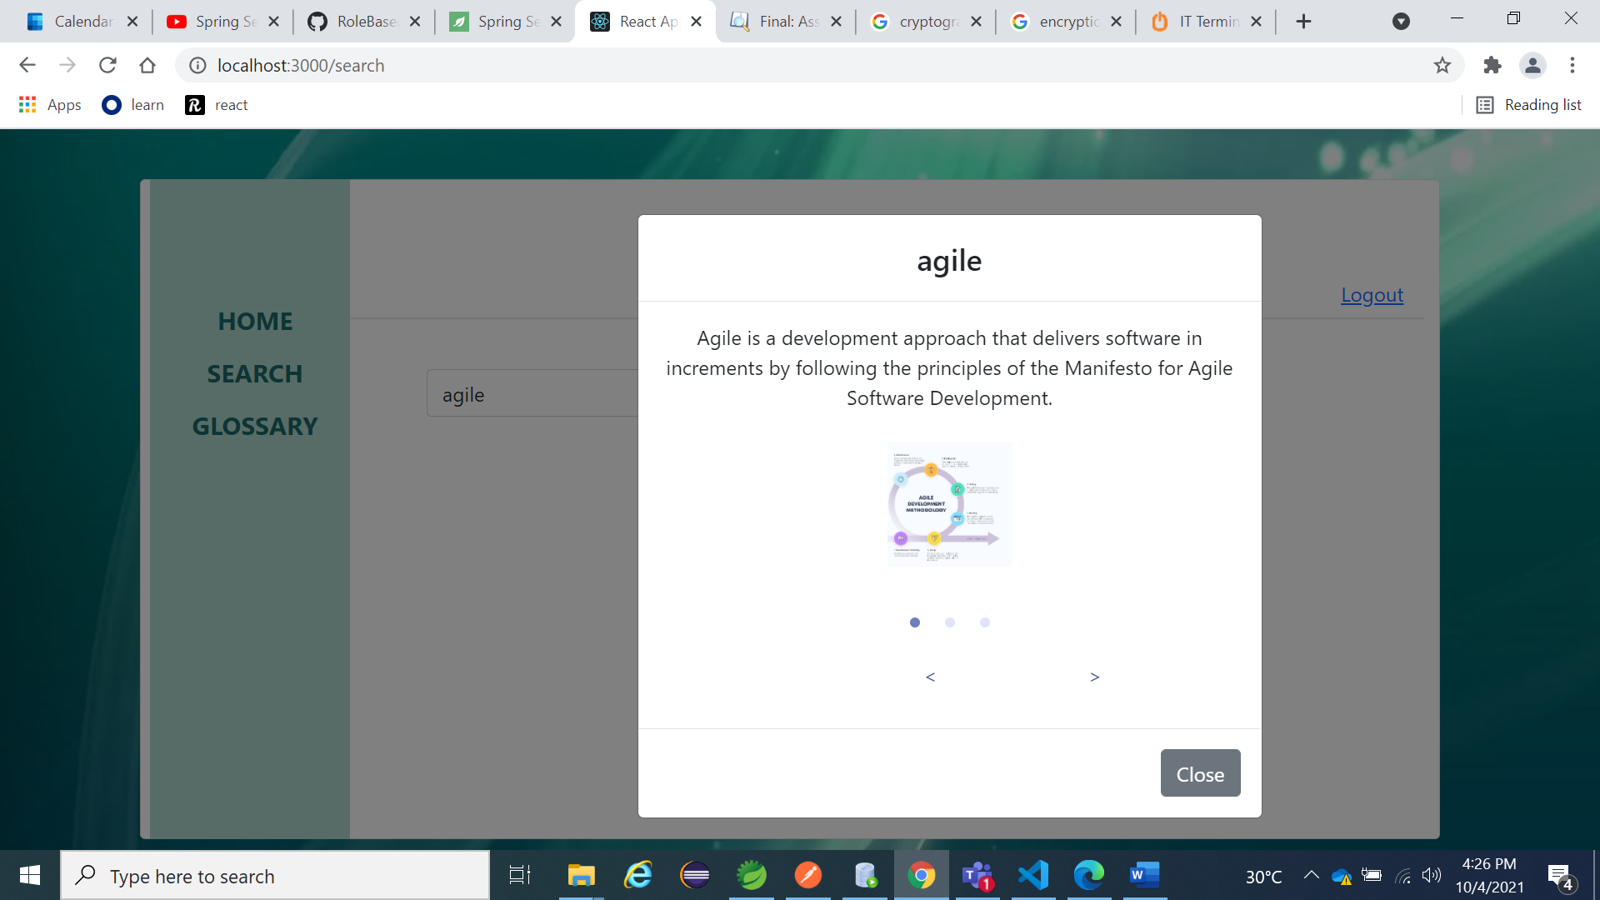

**Admin**

1. For the admin we shall go with the login page, login using the credentials as mentioned in the starting of the file.

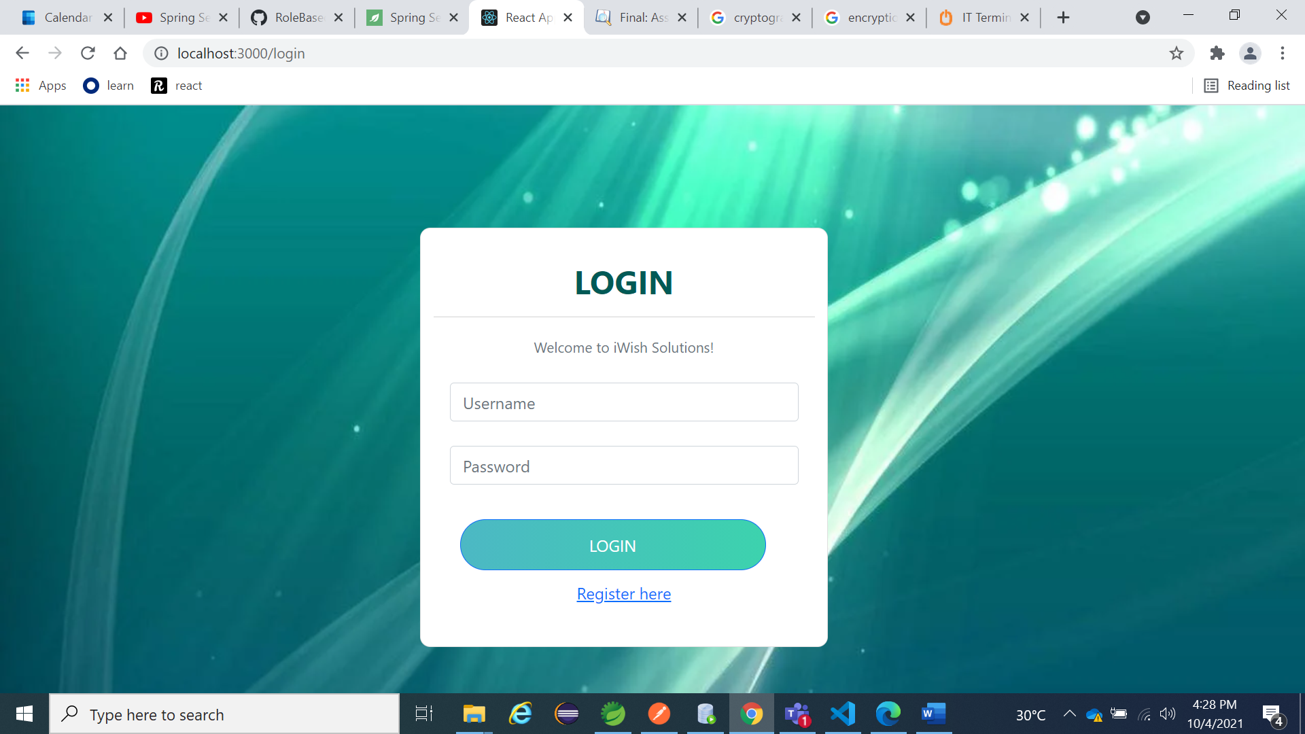

1. After login you’ll be lead to a homepage for the admins.

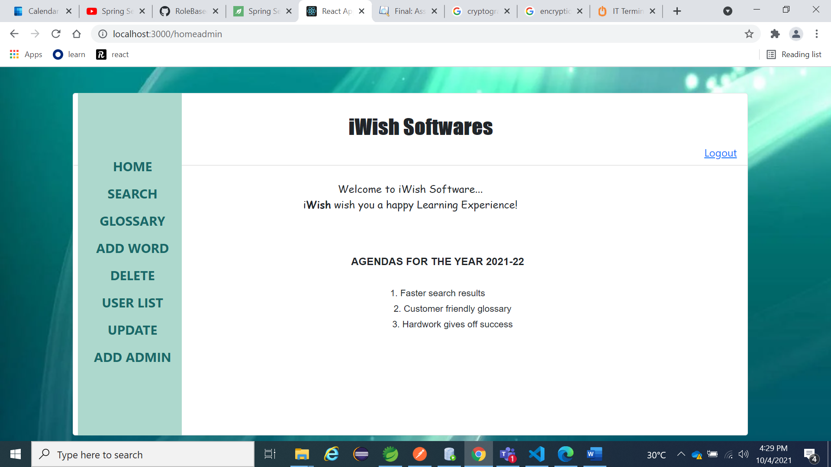

1. The search and Glossary are similar to that of the user portal, so lets move on to the add word, fill the details and you get the success message on clicking the button.

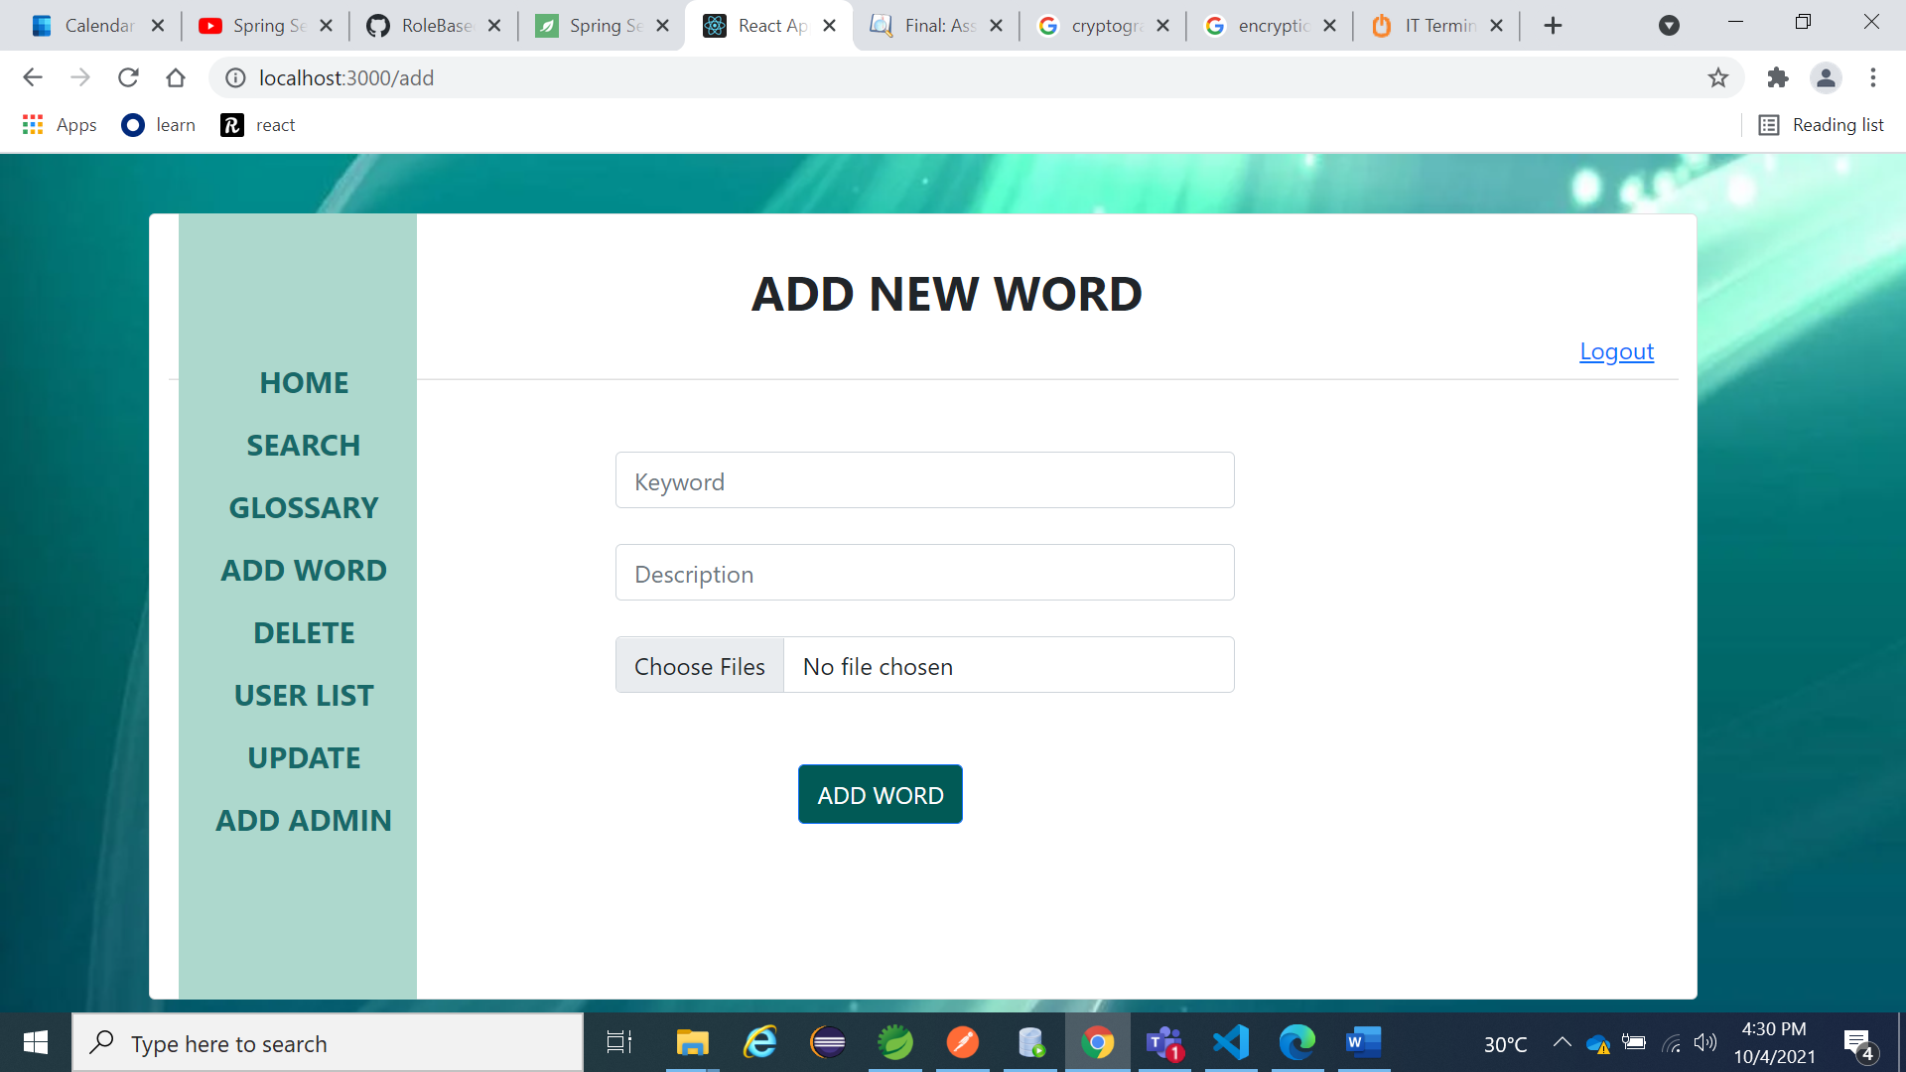

1. The delete page has a search button and a delete button.

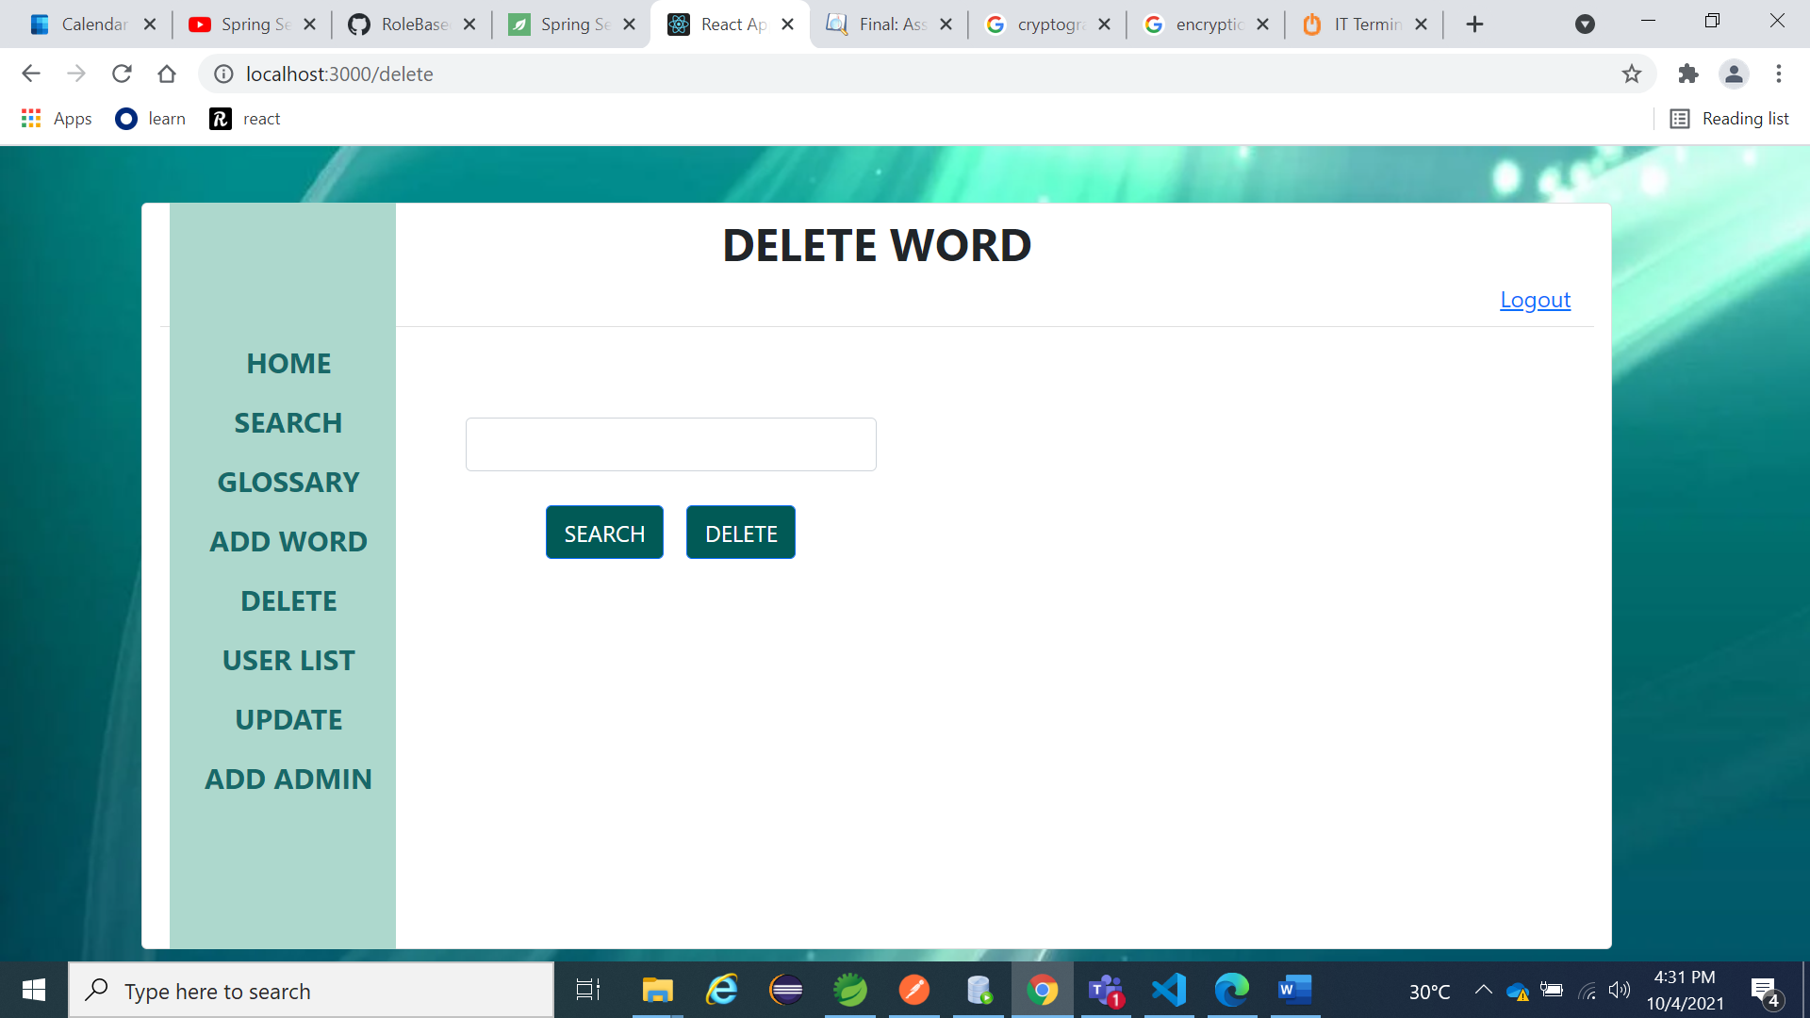

1. Moving on we have the users list which would also include the admins

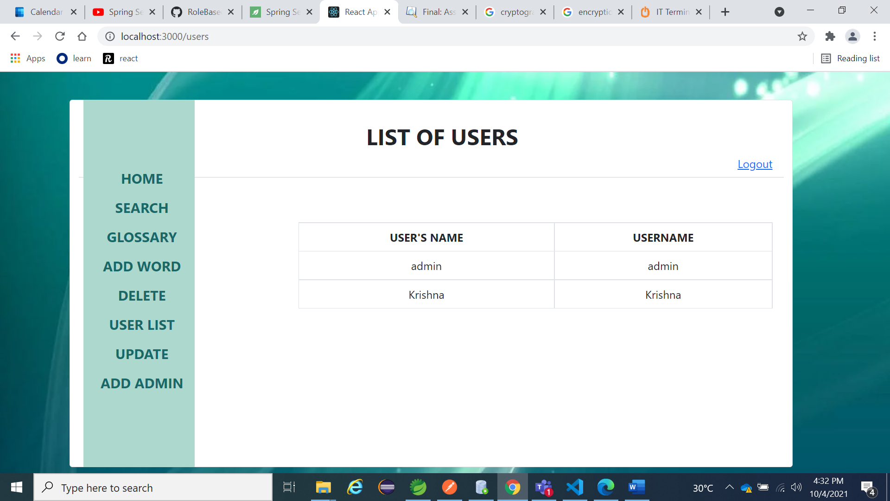

1. The update page has a fetch button which would help you get the description for the word and you could change it as per your wish.

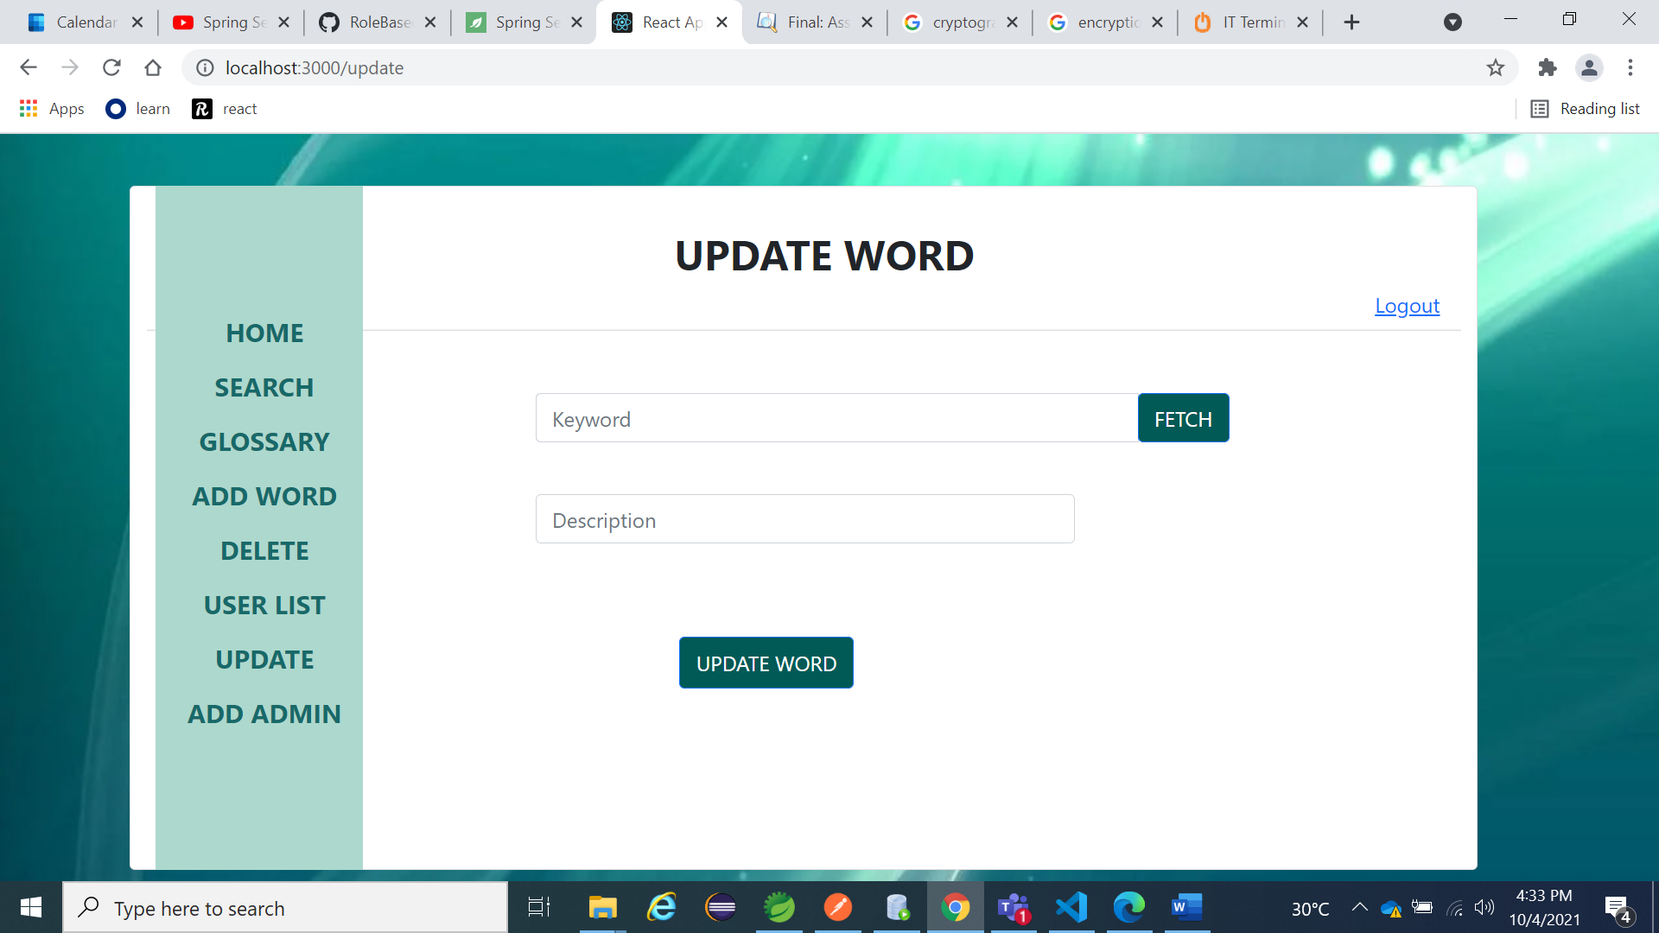

1. And finally, we have the add admin option. **Admin can be added only by another admin.**

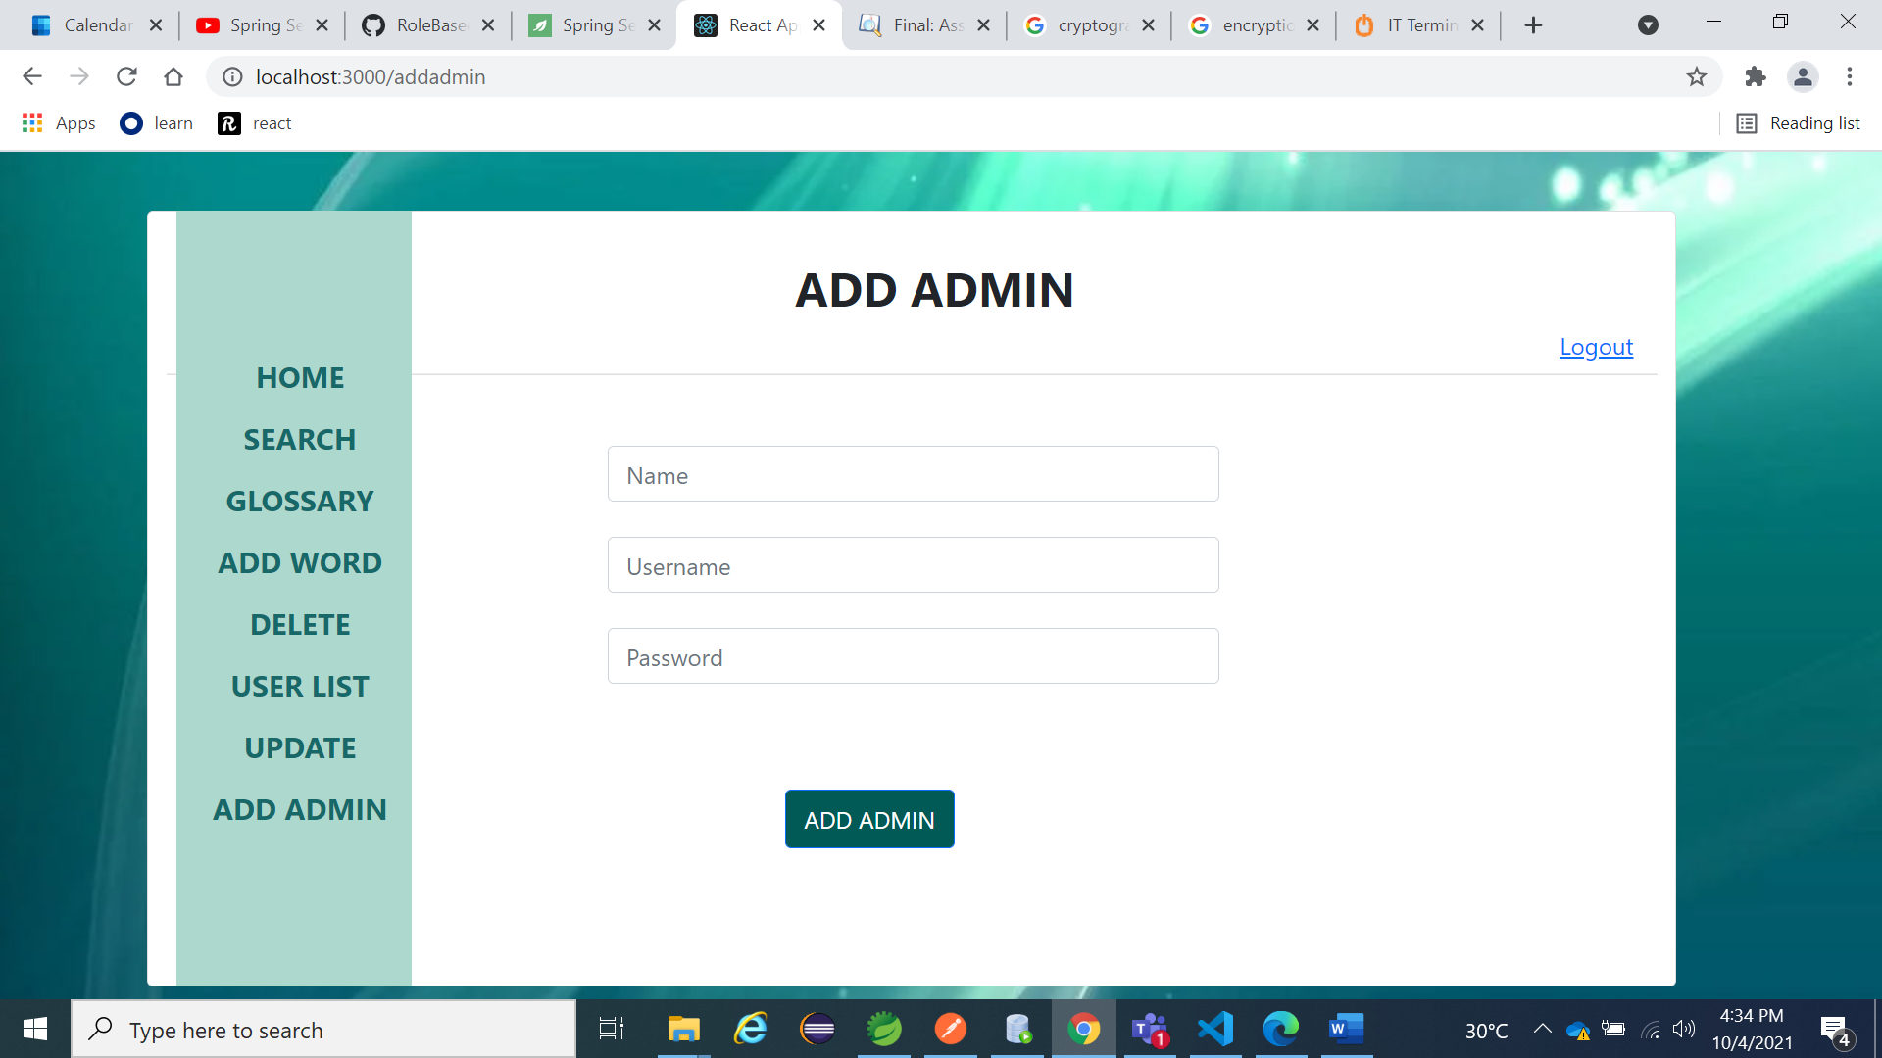

Hope this manual helped you out.

Thank You!